Image Processing Methods for Environment Classification

Rahul Sharma  
 Department of Mathematics and Statistics  
 York University  
 Toronto Ontario Canada  
 rahul494@my.yorku.ca

ABSTRACT

In this sample-structured document, neither the cross-linking of float elements and bibliography nor metadata/copyright information is available. The sample document is provided in “Draft” mode and to view it in the final layout format, applying the required template is essential with some standard steps.

These steps, which should require generation of the final output from the styled paper, are mentioned here in this paragraph. First, users have to run “Reference Numbering” from the “Reference Elements” menu; this is the first step to start the bibliography marking (it should be clicked while keeping the cursor at the beginning of the reference list). After the marking is complete, the reference element runs all the options under the “Cross Linking” menu.

KEYWORDS

Insert keyword text, Insert keyword text, Insert keyword text, Insert keyword text

ACM Reference format:

FirstName Surname, FirstName Surname and FirstName Surname. 2018. Insert Your Title Here: Insert Subtitle Here. In *Proceedings of ACM Woodstock conference (WOODSTOCK’18). ACM, New York, NY, USA, 2 pages.* https://doi.org/10.1145/1234567890

1 Introduction

The updated template, user manuals, samples, and required fonts, all are available at the URL <https://www.acm.org/publications/proceedings-template>. It contains said information for all three versions of MS Word (Windows and 2 versions of Mac). There are also separate links to the user guide, which can be referred to by the user. This URL also contains some useful video links, which describe how to add the template, structure the paper, and generate the layout, in different clips. **Display Formula with Number**

 (1)

**Continuation part of Paragraph Text** The user must style this paragraph in **ParaContinue** style, which follows immediately after the **DisplayFormula** (numbered equation). The **DisplayFormula** style is applied only in case of a numbered equation. A numbered equation always has a number to its right. Insert paragraph text here. **Display Formula without Number**



The **DisplayFormulaUnnum** style is applied only in case of an unnumbered equation. An unnumbered display equation never contains an equation number to its right, and this unique property distinguishes it from a numbered equation.

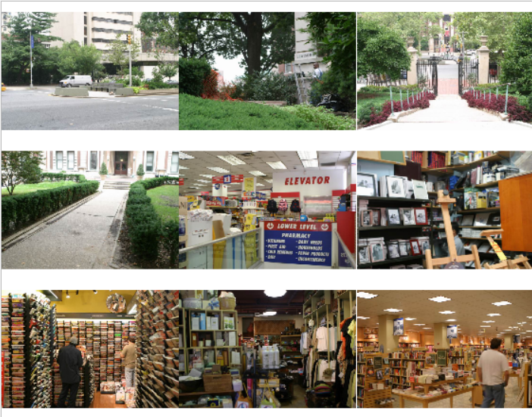

Figure 1: Figure Caption and Image above the caption [In draft mode, Image will not appear on the screen]

**Theorem/Proof/Lemma.** Insert text here for the enunciation or Math statement. Insert text here for the enunciation or Math statement. Insert text here for the enunciation or Math statement. Insert text here for the enunciation or Math statement. Insert text here for the enunciation or Math statement.

....Insert text here for the Quotation or Extract, Insert text here for the Quotation or Extract, Insert text here for the Quotation or Extract, Insert text here for the Quotation or Extract, Insert text here for the Quotation or Extract, Insert text here for the Quotation or Extract.

1.1 Heading Level 2`

In the below paragraph, it is explained how alt-txt value is placed in **MS Word 2010**. To add alternative text to a picture in Word 2010, follow these steps:

1. In a Word 2010 document, insert a picture.
2. Right click on the inserted picture and select the **Format Picture** option.
3. Select the **Alt Txt** option from the left-side panel options.
4. In the "Title:" and "Description:" text boxes, type the text you want to represent the picture, and then click "Close".

Below are steps to place alt-txt value in **MS Word 2013/2016**. To add alternative text to a picture in Word 2013/2016, follow these steps:

1. In a Word 2013/2016 document, insert a picture.
2. Right click on the inserted picture and select the **Format Picture** option.
3. In the settings at the right side of the window, click on the "Layout & Properties" icon (3rd option).
4. Expand **Alt Txt** option.
5. In the "Title:" and "Description:" text boxes, type the text you want to represent the picture, and then click "Close".

*1.1.1 Heading Level 3.* Insert paragraph text here. Insert paragraph text here. Insert paragraph text here. Insert paragraph text here. Insert paragraph text here. Insert paragraph text here. Insert paragraph text here. Insert paragraph text here. Insert paragraph text here. Insert paragraph text here. Insert paragraph text here.

*1.1.1.1 Heading Level 4.*Insert paragraph text here. Insert paragraph text here. Insert paragraph text here. Insert paragraph text here. Insert paragraph text here. Insert paragraph text here. Insert paragraph text here. Insert paragraph text here. Insert paragraph text here. Insert paragraph text here. Insert paragraph text here.

ACKNOWLEDGMENTS

Insert paragraph text here. Insert paragraph text here. Insert paragraph text here. Insert paragraph text here. Insert paragraph text here. Insert paragraph text here. Insert paragraph text here. Insert paragraph text here. Insert paragraph text here. Insert paragraph text here. Insert paragraph text here.

REFERENCES

[1] Patricia S. Abril and Robert Plant, 2007. The patent holder's dilemma: Buy, sell, or troll? *Commun. ACM* 50, 1 (Jan, 2007), 36-44. DOI: <https://doi.org/>10.1145/1188913.1188915.

[2] Sten Andler. 1979. Predicate path expressions. In *Proceedings of the 6th. ACM SIGACT-SIGPLAN Symposium on Principles of Programming Languages (POPL '79)*. ACM Press, New York, NY, 226-236. DOI:https://doi.org/10.1145/567752.567774

[3] Ian Editor (Ed.). 2007. *The title of book one* (1st. ed.). The name of the series one, Vol. 9. University of Chicago Press, Chicago. DOI:https://doi.org/10.1007/3-540-09237-4.

[4] David Kosiur. 2001. *Understanding Policy-Based Networking* (2nd. ed.). Wiley, New York, NY..

Conference Name:ACM Woodstock conference

Conference Short Name:WOODSTOCK’18

Conference Location:El Paso, Texas USA

ISBN:978-1-4503-0000-0/18/06

Year:2018

Date:June

Copyright Year:2018

Copyright Statement:rightsretained

DOI:10.1145/1234567890

RRH: F. Surname et al.

Price:$15.00